Initial Project Proposal

Year: 2023 Semester: Spring Project Name: Engineer’s Chess

Creation Date: November 22, 2022 Last Modified: November 25, 2022

Team Members (#1 is Team Leader):

Member 1: Jack Gardel Email: jgardel@purdue.edu

Member 2: Bazim Azeem Email: bazeem@purdue.edu

Member 3: Tyson Kline Email: kline62@purdue.edu

Member 4: Andy Helton Email: helton4@purdue.edu

1.0 Description of Problem:

The problem we are trying to solve in our project is the inability to play a complete game of chess without making contact with the game pieces. Most chess today is played by picking up pieces and moving them to their desired location. This means that error checking and win detection must be done manually, and sometimes mistakes are made by the human eye. By creating a game of contactless chess, moving the pieces would be unnecessary, and false moves and wins can be detected by a computer. This game of chess should be able to be played by World Chess Championship standards. This most notably means the ability to time the duration of moves made by each player. Many people could benefit from solving this problem, including those with disabilities that make standard chess difficult or impossible or even regular chess players with an interest in a new way to play a classic game.

2.0 Proposed Solution:

Our solution to the problem described above is to create a version of chess controlled by voice commands. A player should be able to give a command, for example, “Queen to D5” and be able to see that command play out in a move on the board. In order to accomplish this contactless moving of pieces, the game board will be created on an LED display. The game package will also contain a timer for each player and a test display for feedback such as invalid commands and win detection. A basic sketch of the game package can be found in Appendix I below. This game will include several main components to accomplish this goal, such as a microphone and signal processor to take voice command inputs, buttons to control starting conditions, seven-segment displays to output the play time, a text display for feedback, and an LED matrix to output the current state of the game. By creating these components, we will solve the problem and create a game of contactless chess.

3.0 ECE477 Course Requirements Satisfaction

3.1 Expected Microcontroller Responsibilities

For the proposed project, there are expected to be two processing units. One of which will be a microcontroller that handles game state, as well as simple I/O for buttons and displays, both for the main chessboard and for status signals. The other processing unit will be a more dedicated unit (such as a single board computer) to handle processes related to signal processing: reading values off the ADC, taking the Fast Fourier Transform of the inputs, matching the frequencies against stored sounds, and transmitting what was said into a code to be sent serially to the primary game microcontroller (i.e. saying “Knight to D5” translates to a binary command of 1101 0011 to the microcontroller).

3.2 Expected Printed Circuit Responsibilities

For the proposed project, the printed circuit board is expected to support a microcontroller and a more complex computational unit, connected through a header interface. Some type of voltage amplification will be necessary for the main display if it draws a lot of power. More space will be available on the board to connect external displays and button switches. The board will be expected to provide for more sensitive analog signals coming from a microphone and heading into a signal processing unit. Additionally, a serial protocol such as I2C or SPI will need to be implemented between the microcontroller and signal processing unit.

4.0 Market Analysis:

According to Chess Redux [1], an estimated 70% of adults globally have played chess sometime in their lives and 15% of adults in the US play chess currently. Fortune Business Insights [2] says that the market for educational toys is said to rise from 68.81B USD in 2021 to 132.62B USD in 2028. With these two metrics, the primary market of chess-playing young adults and children is a strong indicator of future interest. Additionally, new semiconductor fabrication plants are expected to arrive sometime in the near future, driving down prices to acquire the multiple processing components of this design. Abachy [3] points out that TSMC has started construction on a fabrication plant in Japan, scheduled for completion in 2024.

5.0 Competitive Analysis:

5.1 Preliminary Patent Analysis:

There are patents and products on the market that can currently have overlap with the proposed project. While many of these patents have some similar overall uses, many of the specifics have very little connection to the project and will not be roadblocks to navigate around.

5.1.1 US Patent Application, US 11468890 B2:

**Patent Title:** “Methods And User Interfaces For Voice-based Control Of Electronic Devices”

**Patent Holder:** Apple Inc.

**Patent Filing Date:** May 29th, 2020

This patent [4], assigned to Apple Inc., relates to the use of electronic devices with voice control. As such, this gives the users of said devices the ability to manipulate the device with their voice in addition to regular functions. The specific uses outlined in the patent, allow for many uses from speech-to-text to device operations. However, while this covers many facets, this type of implementation can be too broad. With too many instructions, complex or simple, ease of which a user can use said device becomes increasingly more difficult. The disadvantages of this is the number of tasks that can be performed can become too large and tedious to memorize for a user. The advantages of this implementation are also in how much a user can do with just their voice, barely having to have any tactile interactions with the device they are operating. The patent claims specify how the graphical output of the voice commands is displayed, by using other display methods there will be no infringement on the claims of the patent.

5.1.2 US Patent Application, US 11468890 B2:

**Patent Title:** “Interactive Play Apparatus”

**Patent Holder:** LEGO A/S

**Patent Filing Date:** October 16th, 2018

This patent [5], filed by LEGO A/S, is for the use of interactive toys using multiple devices and user inputs to get the desired outcome. One of the main uses for this patent was for the ability to use voice commands to control the toy. This patent covers a wide array of interactive uses, including but not limited to voice commands and/or activation. The claims within the patent itself indicate that they do not cover all voice controlled toys/games. Knowing these, the proposed project's likelihood of infringement on this patent is low, despite some high level similarities.

5.1.3 US PAtent Application, US 20200282297 A1:

**Patent Title: “**Electronic Game Board”

**Patent Holder:** N/A

**Patent Filing Date:** September 10th, 2019

The privately filed patent [6], specifies the input of either one or more players that controls the movement of game pieces on top of a given playspace. The patent also briefly mentions the ability to use voice-operated commands to use the game board, which would then tell a robotic arm to control the game pieces. The advantages of this, is that it allows the users to have a physical play space with physical pieces. The disadvantage is the arm, this brings in many moving parts and unforeseen game styles that may not be able to be handled correctly by the robotic arm. However, using voice commands for a chess game, with a digital display, allows for more consistent gameplay and decreased risk of mechanical problems.

5.2 Commercial Product Analysis:

After a thorough search for competing commercial products, none were found. Much of the work done in the area of voice activated chess boards has been open source projects. We did, however, find some computer applications that enable this functionality. While these implementations are able to take advantage of a more powerful CPU, they do not provide a physical board, which is a key distinguishing feature of this project.

5.3 Open Source Project Analysis:

The idea of designing a voice activated chess board seems to be a popular project idea. There are many open source projects that implement this functionality. Three such projects are outlined below.

5.3.1 Wizard Chess:

This was a semester project completed by a team of five students at Queen’s University for their CMPE 325 course [7]. The project uses an offline library named Snowboy to recognize key phrases (such as to start the board) and uses Google speech recognition to recognize chess commands. In addition, the implementation includes motors and magnets to physically move the pieces. Some disadvantages include the fact that the device must be connected to Wifi and to an outlet for power. This makes it much less mobile and versatile. Furthermore, the project is rather large in the z-direction. Below is an image of the mechanical execution for moving pieces.

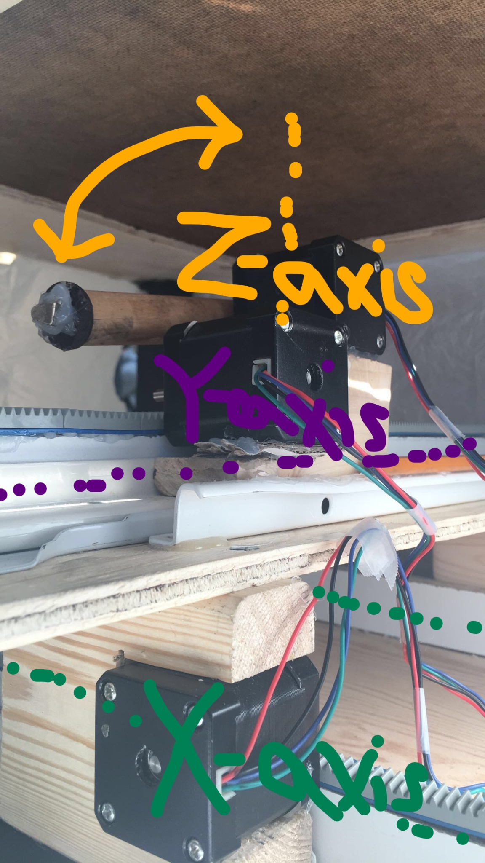

5.3.2 Voice Activated Chess Set:

This project was an honors research project at the University of Akron by a team of four students [8]. It uses three processors: a voice activation module for communicating with the player, a microcontroller that manages the chess game and keeps track of pieces, and a positioning system which takes in the source and destination and provides output to the motors to move the pieces. This diagram shows the systems:

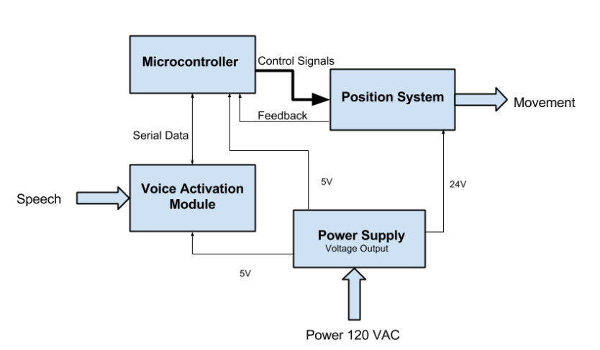

Some of the disadvantages of this project include that it was very heavy due to the large amount of components, making it less portable. Furthermore, it would have been better if the product was more neatly packaged.

5.3.3 Chess Express: The Voice-Controlled Moving Chessboard:

This project was designed by a pair of students at the University of Illinois Urbana-Champaign for their ECE 445 senior design lab [9]. It uses an ESP32 microcontroller to implement the chess logic, voice processing, and motor control. Furthermore, this project has a feature which allows for online play between two Chess Express Units. A disadvantage of this design is its lack of refinement in design, as shown in the image of the final product below.

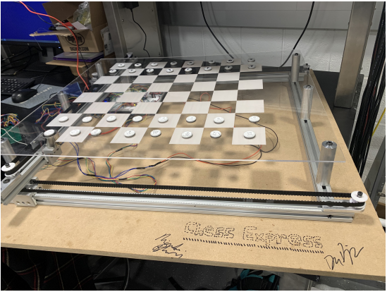

6.0 Sources Cited:

[1] Chess Redux: How Many People Play Chess?, by ChessBase (2012, August 8th)

<https://en.chessbase.com/post/che-redux-how-many-people-play-che->

[2] Educational Toys Market Size, Share & COVID-19 Impact Analysis, by Fortune Business Insights

(2022, February)

<https://www.fortunebusinessinsights.com/educational-toys-market-106324>

[3] New Semiconductor Fabs Coming In The Next 5 Years, by Abachy

<https://abachy.com/news/new-semiconductor-fabs-coming-next-five-years>

[4] Methods and User Interfaces for Voice-Based Control of Electronic Devices, by V. Jigar and M. Hatem. (2020, May 29th). US 11468890 B2. Available: <https://patents.google.com/patent/US20220139396A1/en?oq=20220139396>

[5] Interactive Play Apparatus, by E. Hansen and J. Søderberg and T. Donaldson and M. Jensen. (2018, October 16th). US 11433302 B2. Available: <https://ppubs.uspto.gov/pubwebapp/>

[6] Electronic Game Board, by A. Mehta and D. Gehlot and B. Gohil. (2019, September 10th). US 20200282297 A1. Available: <https://uspto.report/patent/app/20200282297>

[7] Wizard Chess, by T. Heysel and A. Christensen and R. Kinsella and M. Roux and D. Grajo (2019). Available: <https://github.com/Ryan-Kinsella/Harry-Potter-inspired-voice-activated-chess/blob/master/FINALCHESS.pdf>

[8] Voice Activated Chess Set, by W. Weigand and A. Jansto and K. Bojadzija and M. Hall (2016). Available: <https://ideaexchange.uakron.edu/cgi/viewcontent.cgi?article=1356&context=honors_research_projects>

[9] Chess Express: The Voice-Controlled Moving Chessboard, by D. Biskup and A. Rajan (2020). Available: <https://courses.engr.illinois.edu/ece445/getfile.asp?id=16689>

Appendix 1: Concept Sketch

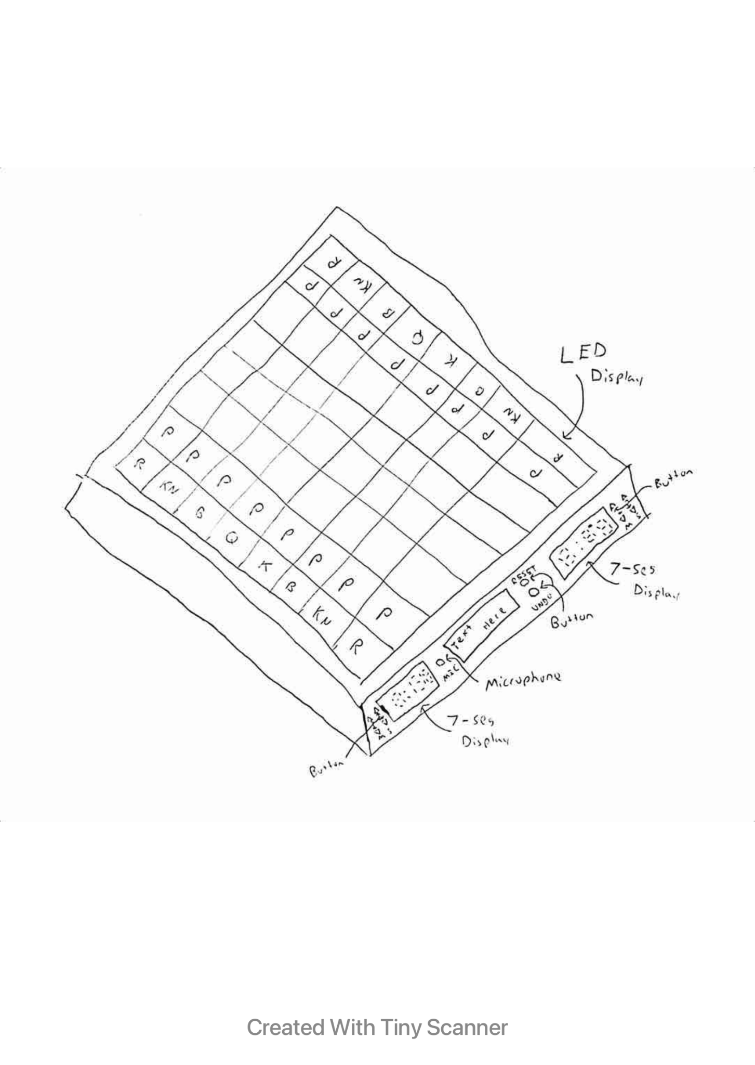

Figure 1: Design Package Sketch

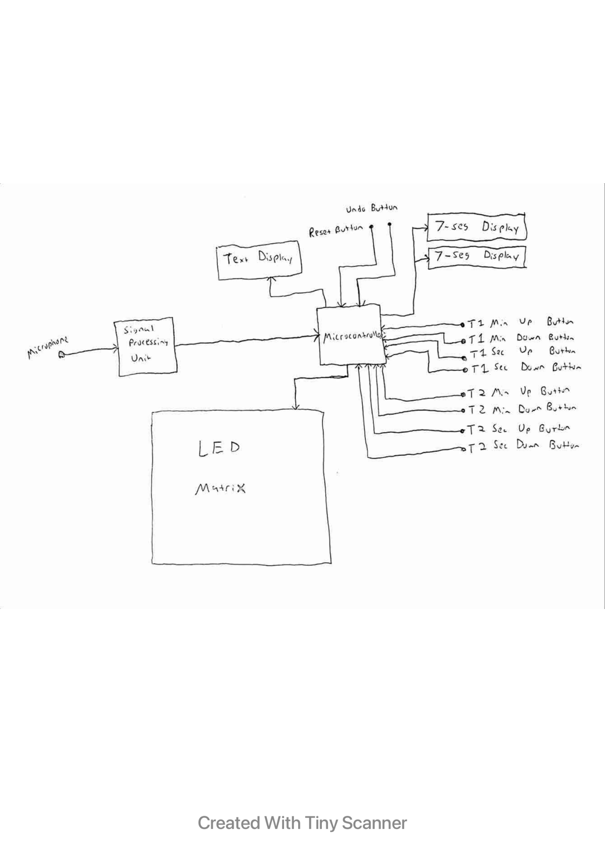

Figure 2: Design Diagram Sketch